**Experiment no. 9**

Aim: To implement Association Rule Mining Algorithm (Apriori).

Requirements: Windows OS and Weka Tool.

Problem Statement: To implement Apriori algorithm on Supermarket data set using Weka Tool.

Theory:

Apriori Algorithm:

The Apriori algorithm uses frequent item sets to generate association rules, and it is designed to work on the databases that contain transactions. With the help of these association rule, it determines how strongly or how weakly two objects are connected. This algorithm uses a breadth-first search and Hash Tree to calculate the item set associations efficiently. It is the iterative process for finding the frequent item sets from the large dataset.

This algorithm was given by the R. Agrawal and Srikant in the year 1994. It is mainly used for *market basket analysis* and helps to find those products that can be bought together. It can also be used in the healthcare field to find drug reactions for patients.

What is Frequent Item set?

Frequent item sets are those items whose support is greater than the threshold value or user-specified minimum support. It means if A & B are the frequent item sets together, then individually A and B should also be the frequent item set.

Suppose there are the two transactions: A= {1,2,3,4,5}, and B= {2,3,7}, in these two transactions, 2 and 3 are the frequent item sets.

Steps for Apriori Algorithm:

Step-1: Determine the support of item sets in the transactional database, and select the minimum support and confidence.

Step-2: Take all supports in the transaction with higher support value than the minimum or selected support value.

Step-3: Find all the rules of these subsets that have higher confidence value than the threshold or minimum confidence.

Step-4: Sort the rules as the decreasing order of lift.

Output**:**

Supermarket data set:

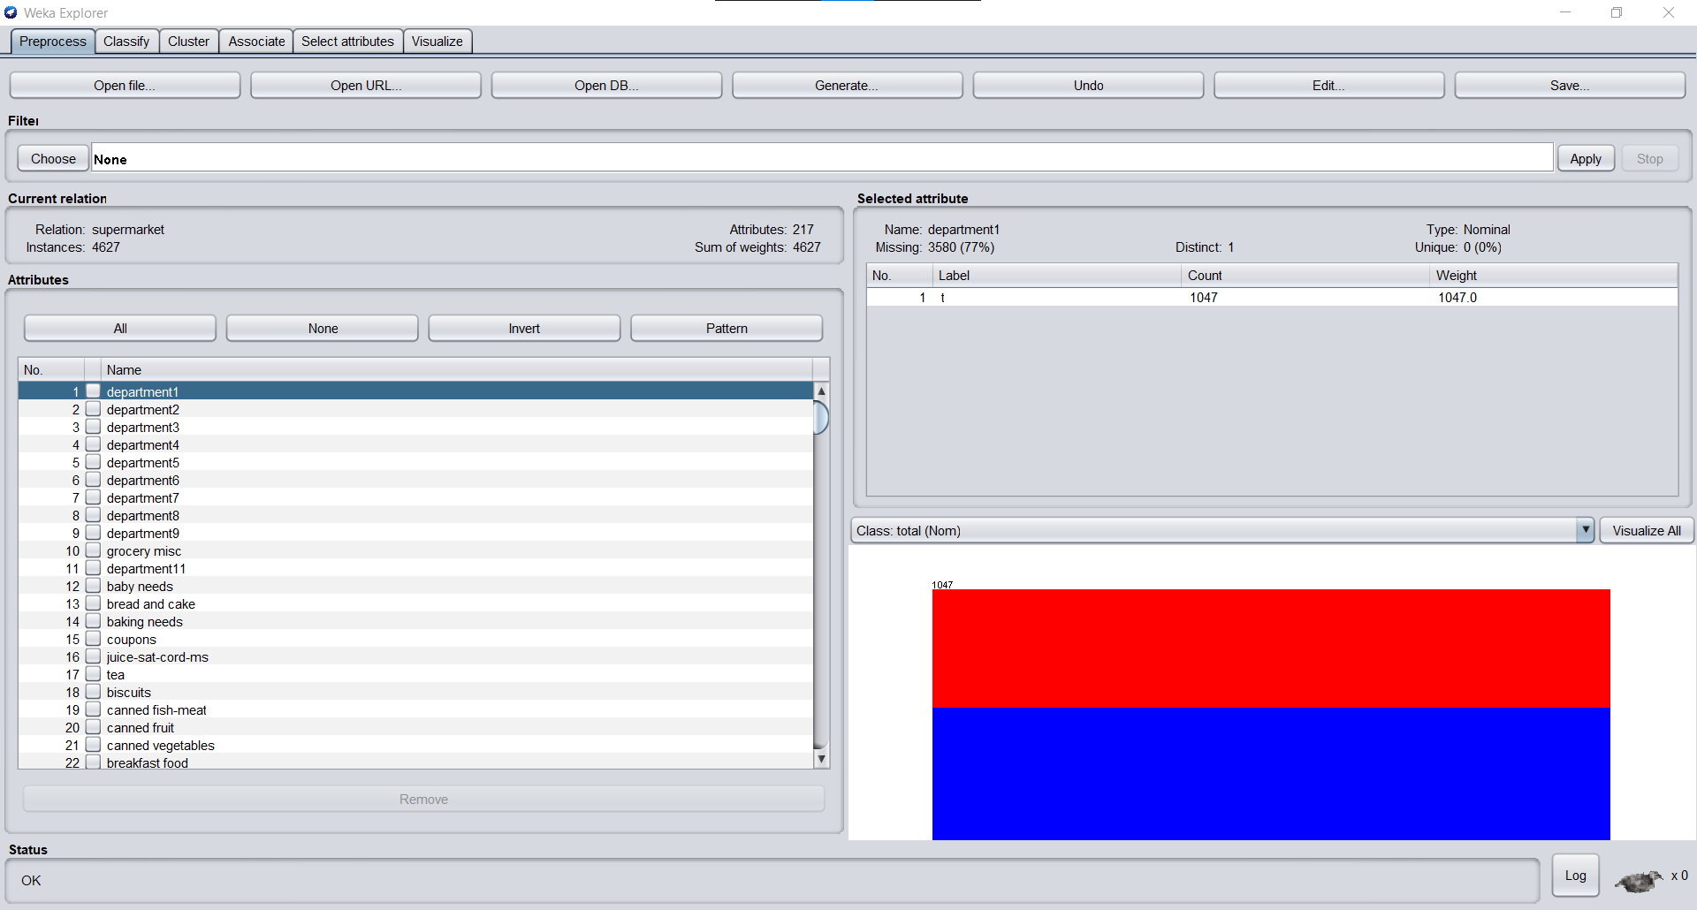

Parameter of Apriori algorithm:

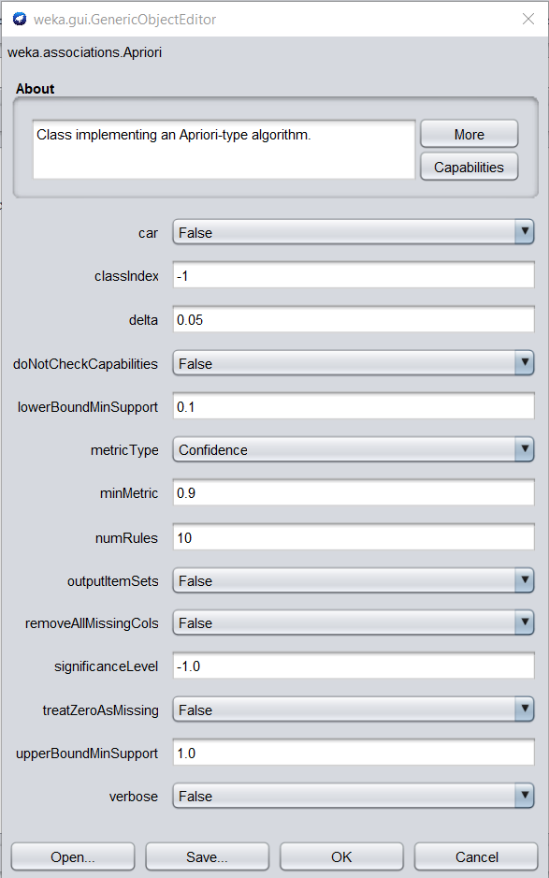

Result:

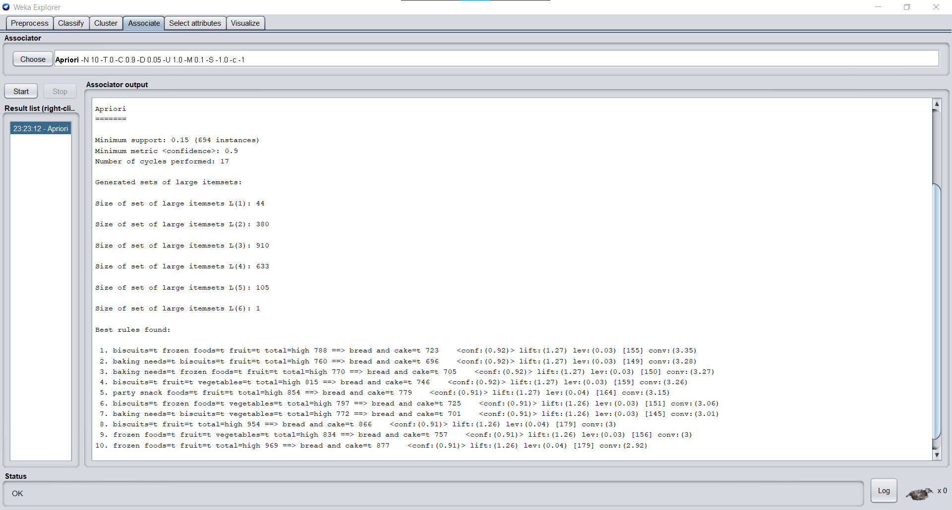

Conclusion: We have successfully implemented Apriori algorithm on supermarket data set using Weka Tool.